Unit 5: Sightseeing holidays

**A ‣ Things to see**

1. 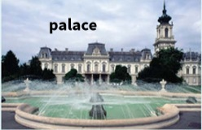  
   **fountain**
2. 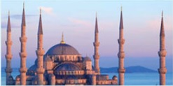  
   **mosque**
3. 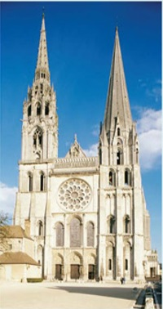  
   **cathedral**
4. 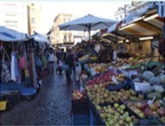  
   **market**
5. 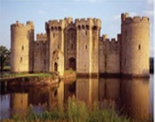  
   **castle**
6. 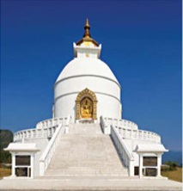  
   **temple**
7. 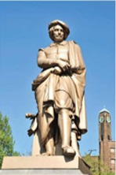  
   **statue**

**B ‣ Tourist activities**

|  |  |
| --- | --- |
| **activity** | **example** |
| **go sightseeing** [visit famous places; also **see the sights**] | We **went sightseeing** almost every day. I like to **see the sights** when I visit a place. |
| **do**a bit of / a lot of **sightseeing** | I didn’t **do**a lot of **sightseeing**in Warsaw. |
| **have a look round**[visit a place casually, often on foot] | We **had a look round** the shops. I want to **have a look round** the museum. |
| **explore**[go round a new place to see what is there] | We **explored**the flower market. |
| **go out** [leave home / your hotel to go to a social event, e.g. restaurant or theatre] | On holiday we **went out** every night. |
| **get lost**[lose one’s way] | I **got lost** three times in London. |
| **have**a great/nice/terrible **time** | They **had a lovely time**in Venice. |
| buy **souvenirs**[something you buy or keep to remember a place or holiday] | We bought some dolls as **souvenirs**. |

**C ‣ Describing places**

The word **place**can describe a building, an area, a town, or country, e.g. Bruges is a lovely **place**[town] and we found a really nice **place**[hotel] to stay.

“The **guidebooks**[books with information about places] say the Alhambra in Granada is **magnificent**[very good or very beautiful], but it’s always **packed**[very crowded] with tourists in the summer.”

“São Paulo is a **lively**place [full of life and activity], and there’s **plenty**[a lot] to do in the evening.”

“St Petersburg has lots of **historic monuments** [important places built a long time ago] but the Hermitage Museum was the main **attraction**for me. [something that makes people come to a place or want to do a particular thing]”

“If you go to Poland, it’s definitely **worth**visiting Kraków.”

Language help

We use **worth**+ noun/-*ing*to say that it is a good idea to do something or go somewhere.

*It’s****worth****hiring a car if you go to Scotland. Glasgow is****worth a visit****as well.*

**VOCABULARY**

* **attraction**
* **castle**
* **cathedral**
* **do a bit/lot of (sightseeing/hiking etc.)**
* **explore**
* **fountain**
* **get lost**
* **go out [social activity]**
* **go sightseeing**
* **guidebook**
* **have a great/nice/terrible time**
* **have a look round**
* **historic monument**
* **lively**
* **magnificent**
* **market**
* **mosque**
* **packed**
* **palace**
* **place [town/building]**
* **see the sights**
* **sights**
* **sightseeing**
* **statue**
* **temple**
* **worth (+ noun/-ing)**

**Exercises**

**50.1 ‣ Tick (x) the words which refer to religious places.**

1. church
2. castle 
3. statue 
4. fountain 
5. market 
6. mosque 
7. temple 
8. cathedral 
9. palace 

**50.2 ‣ Complete the email.**

From: John H.  
  
Hi everyone,  
  
I’ve been in Paris for over a week now and I’m having a great 1. I did quite a lot of 2  in the first few days – the Eiffel Tower, Notre-Dame, and all the usual tourist 3 . Most places are absolutely 4  with tourists at the moment, so yesterday I decided to 5  one or two shopping areas. I got 6  on my way back to the hotel, but it didn’t matter because I discovered a really fascinating street 7  selling just about everything from apples to antiques.  
  
I ate in the hotel the first night but I usually 8  for dinner – the restaurants are great and I can get a set meal for €20.  
I hope you’re all well. I’ll write again in a few days.  
  
All the best, John

**50.3 ‣ Complete the dialogues, but without using a word from the question.**

1. A: It’s a fabulous city, isn’t it?  
   B: Yes, it’s a wonderful .
2. A: It was very crowded, wasn’t it?  
   B: Yes, it was absolutely .
3. A: It’s lively in the evening, isn’t it?  
   B: Yes, there’s .
4. A: Did you enjoy yourselves?  
   B: Yes, we had a .
5. A: Kyoto is a good place to go to, isn’t it?  
   B: Yes, Kyoto is definitely .
6. A: You know a lot about this castle, don’t you?  
   B: Yes, I bought a .
7. A: St Petersburg has got many famous old places to see, hasn’t it?  
   B: Yes, lots of historic .
8. A: The Taj Mahal was impressive and so beautiful.  
   B: Yes, it was .
9. A: Did you explore the town centre?  
   B: Yes, we had a .

**50.4 ‣**

Over to you

**Think about your own country and write answers. If possible, compare your answers with someone else.**

1. Write down a place that is worth visiting and a place that is not worth visiting and say why.
2. Is there a place that is particularly famous for its historic monuments? What are they?
3. What typical souvenirs do tourists buy when they visit?
4. What are the main attractions for tourists to your country? Do you think they are worth seeing?